.rpm is the package name and tools to manage the package is yum/dnf and rpm

Become root before doing this exercise

1. List all the installed rpm packages

a. rpm -qa | more

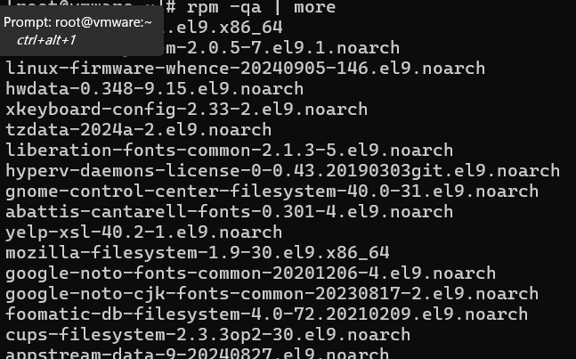

b. rpmquery -a | more

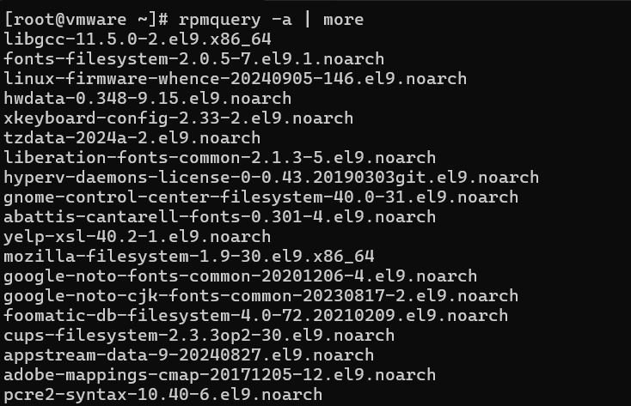

c. rpm -qa | wc -l



d. rpmquery | wc -l



e. rpm -qa –last

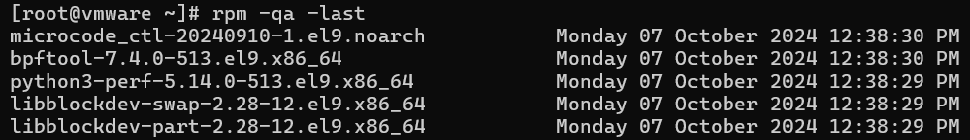

2. Check whether acl ,shadow-utils,passwd,firewalld package is installed

a. rpm -qa acl



b. rpm -qa | grep acl

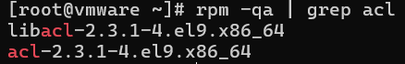

c. rpmquery acl



d. rpmquery -a | grep acl

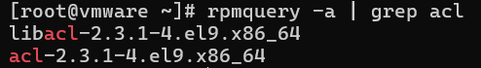

e. rpm -q | grep acl

3. Repeat the 2.a –e for shadow-utils,passwd and firewalld

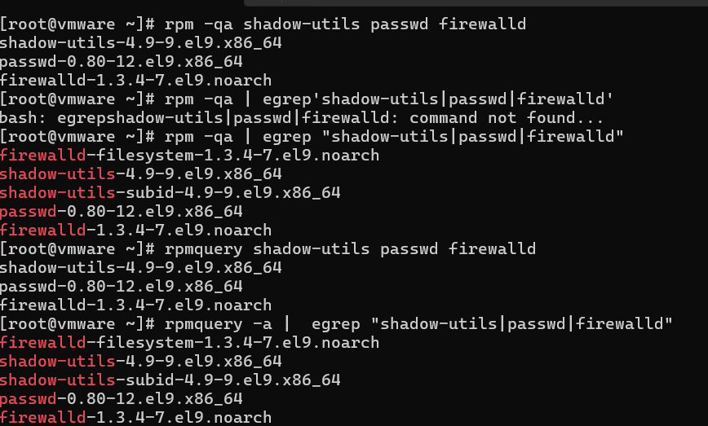

4. Install vsftpd package

a. Download the package from internet (vsftpd-3.0.3-49.el9.x86_64.rpm CentOS 9

Stream Download (pkgs.org))

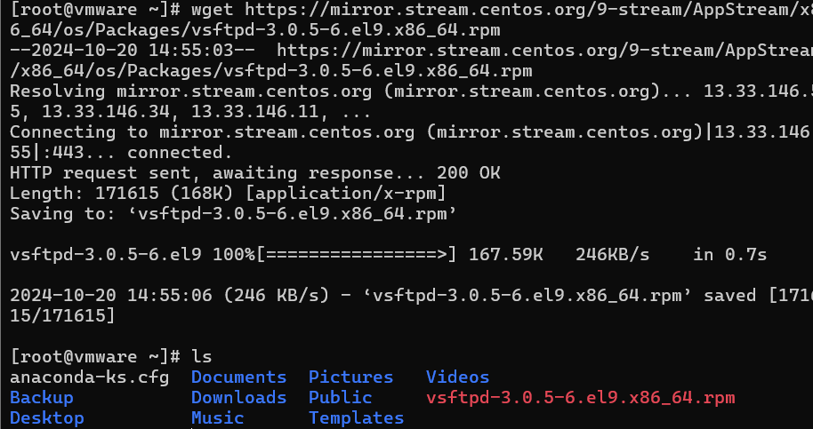

b. Install using rpm -ivh vsftpd…..rpm

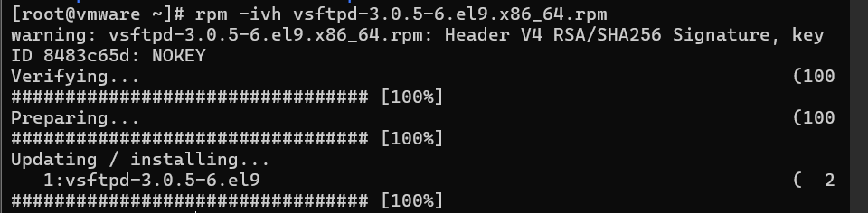

5. Download Apache server – httpd package and before installing

a. Check for dependencies using – rpm -qRp packagename

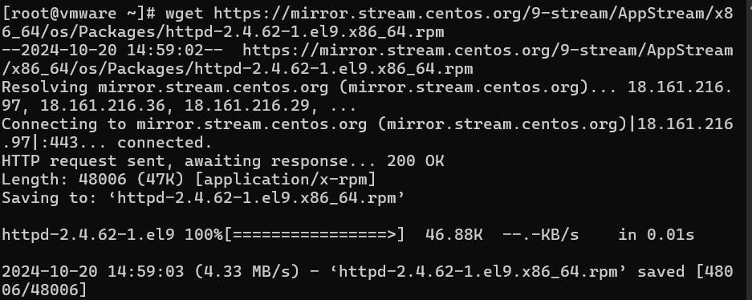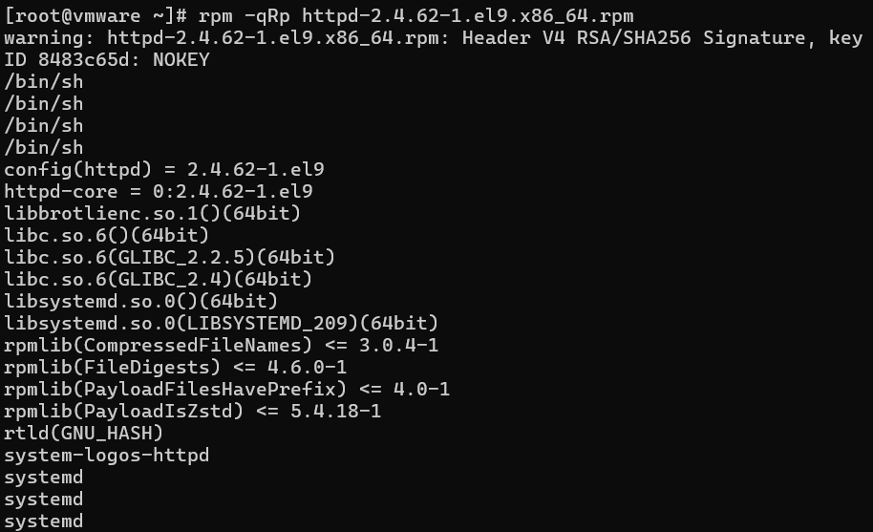

b. Get info abt the package using – rpm -qip packagename

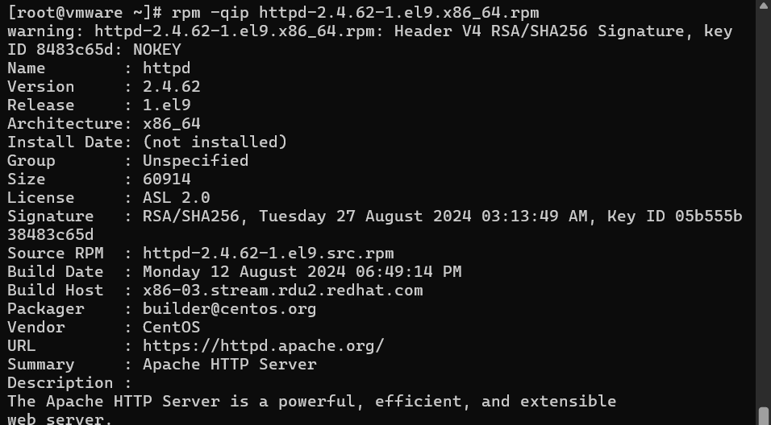

c. Get the config files using – rpm -qcp packagename

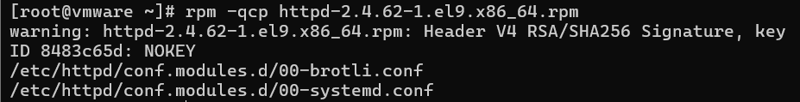

d. Get the docs using -rpm -qdp packagename

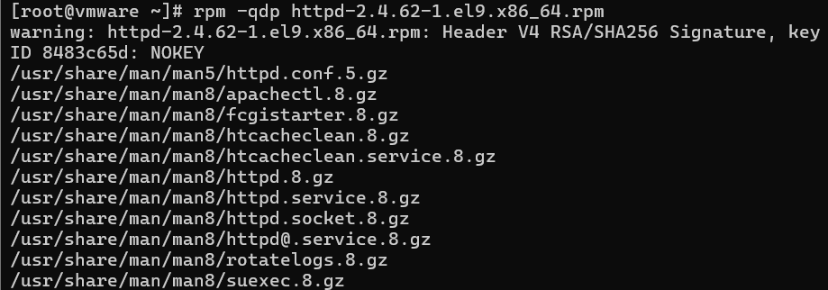

6. Install httpd packager

Ans: it ask dependencies to install httpd

7. List all files of the package using – rpm -ql vsftpd

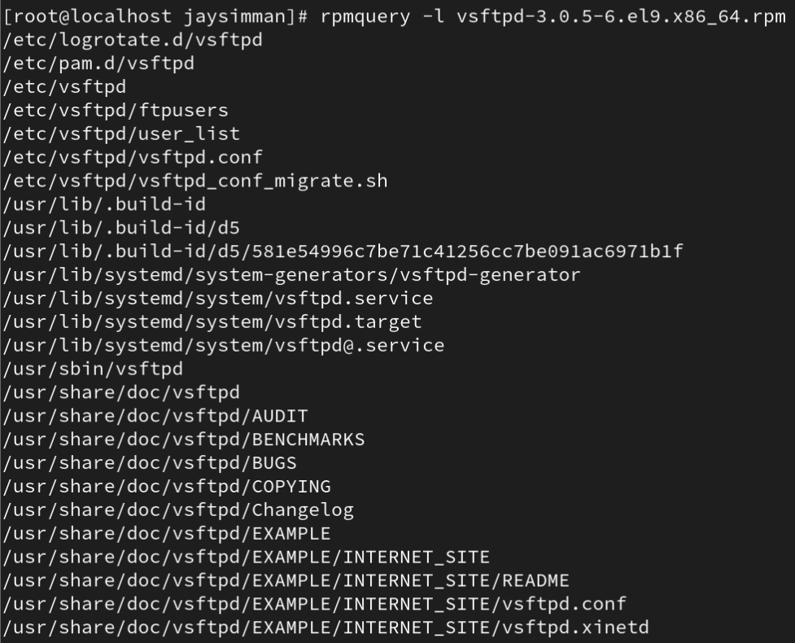

8. Upgrade an rpm package using – rpm -Uvh packagename

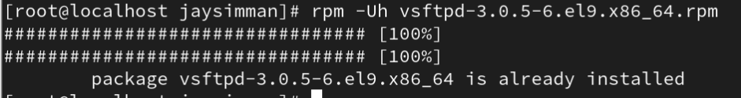

9. Get info about the installed rpm package using rpm -qi packagename

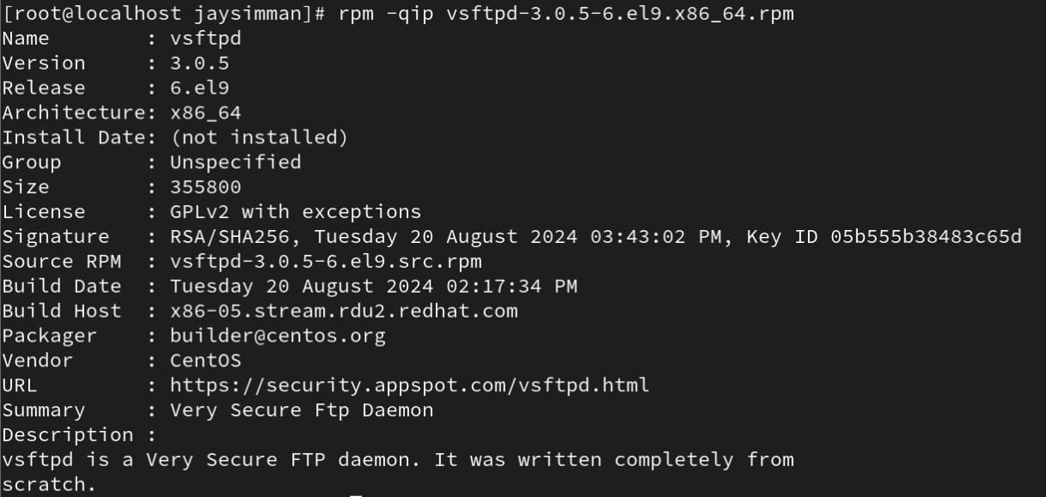

10. Query the files that belongs to which rpm package

a. rpm -qf /usr/sbin/useradd



b. rpm -qf /etc/vsftpd



c. rpm -qf /usr/bin/passwd



d. rpm -qf /usr/bin/getfacl



11.List the doc and config files of the installed packages

a. rpm -qcf /usr/bin/passwd



b. rpm -qdf /usr/bin/passwd

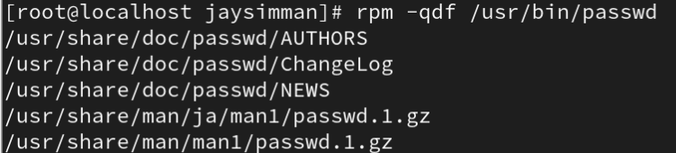

c. rpm -qcf or -qdf /etc/vsftpd

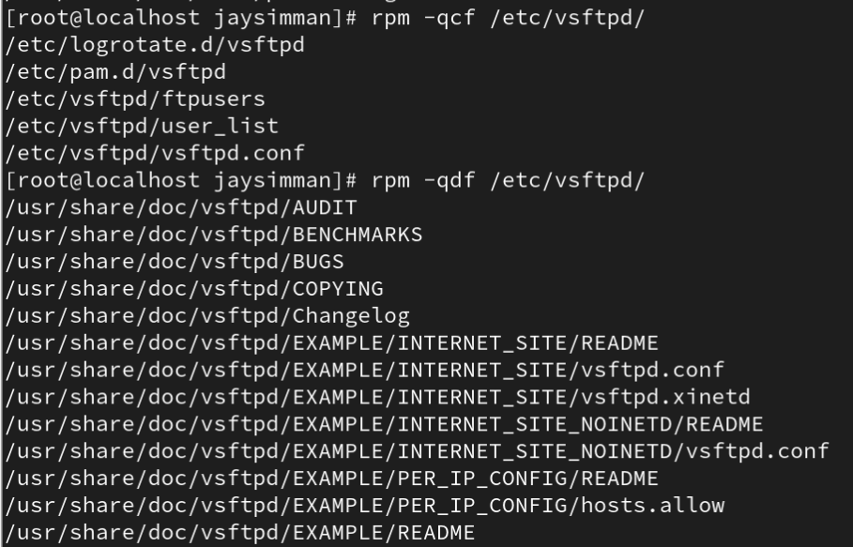

12.Remove the package using – rpm -evv or -evh packagename



13.Remove the package without checking for dependencies

a. rpm -ev –nodeps packagename (nodeps option should be used very carefully as

it will remove the package even if it is a dependency for other packages)



14.Query Format – display columns

a. rpm -qa –queryformat ‘%{name}---%{release}---%{version}\n’ | more

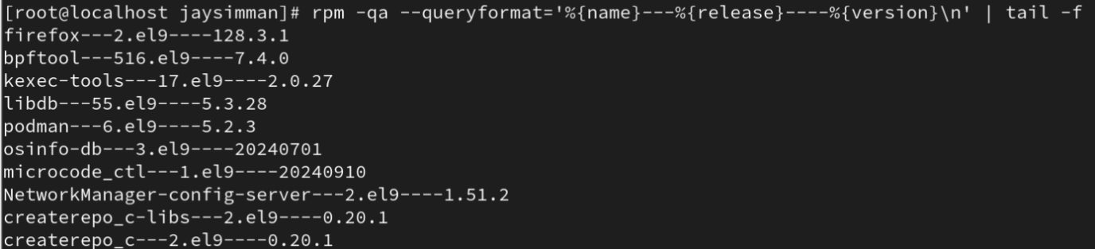

b. rpm -qa –queryformat ‘%{name}---%{size}---%{release}\n’ | more

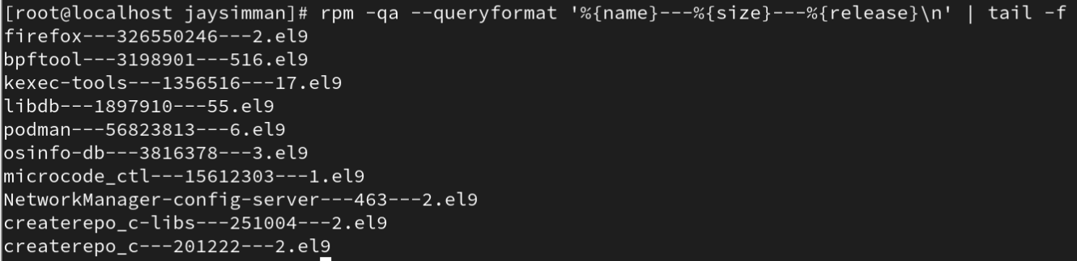

c. rpm -qa passwd –queryformat ‘%{name}---%{size}---%{release}\n’



d. rpm -qa acl –queryformat ‘%{name}---%{size}---%{release}\

